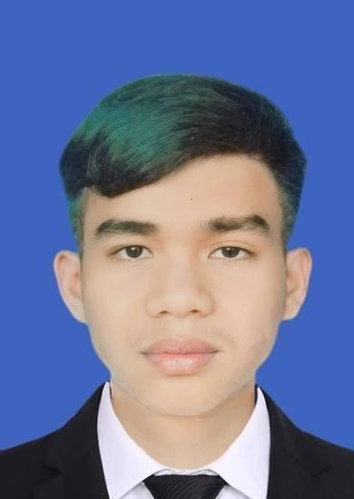
Name: TOLA
Apply: IT Support Staff and IT Support
Contact
Address:
Sangkat Stueng Mean Chey 3, Khan Mean Chey,PhnomPenh, Cambodia Phone:
+855 719389891

Email: Sambathtola04@gmail.com telegram: https://t.me/sambathtola19

Languages
Khmer : Native
English: BasicIntermediate Reading & Understanding
Hobbies
- Writing
- Sketching
- Photography

Summary
Entry-level IT Support student currently studying Information Technology at RUPP.Basic knowledge in computer hardware, software installation, networking fundamentals, and troubleshooting.Highly motivated, fast learner, and willing to grow in a professional IT environment.

Skill Highlights

- Project management
- Strong decision maker
- Complex problem solver
- Windows installation

- Booster
- Program
- Research

- Project management
- Strong decision maker
- Complex problem solver
- Computer hardware (PC, printer, cable
- Basic Networking
- Word,Excel,powe rpoint

Experience
Stock Officer & Cashier – Lucky Supermarket (2024)
- Managed stock system and product records
- Worked accurately under pressure
Cashier – Midtown Mall (2025)
- Used POS systems and handled dailytransactions
              - Assisted customers and solved basic system issues
              - Improved communication and problem-solving skills

Education
2017-2023 :Graduated from Chan Krishna High School
2023-2025 : Continuing to study Information Technology Certificate (rupp)

Reference
Mr: SAMBATH
Telephone:0979580142

